November 2009
M E M O R A N D U M
Attachment D

TO: Emergency Medical Services (EMS), Fire Department and Law Enforcement Personnel
FROM: Audrey L Stein, Program Consultant, Injury Prevention Program
Division of Emergency Preparedness & Response
RE: Teddy Bear “You Don’t Have to Bear It” Sticker Program
_________________________________________________________________________________________________

The Injury Prevention Program is pleased to announce that the Teddy Bear Sticker Program will continue during FFY 2010. By participating in the Teddy Bear Sticker Program, you help us document serious injuries prevented and children’s lives saved as a result of our statewide Mini-Grant program that provides child safety seats and education in their proper use to low income families in Georgia. Collecting this data is essential to justify future funding and to help ensure that these programs continue. The Teddy Bear Sticker Program is a great way to help a family that has been involved in a motor vehicle crash. It's also a way for your agency to acquire educational items for your injury prevention programs.

Your agency can participate in the Teddy Bear Sticker Program by completing the Fax Back Form and faxing it to us. You should complete the form each time your agency responds to a motor vehicle crash involving a child age 8 or younger.

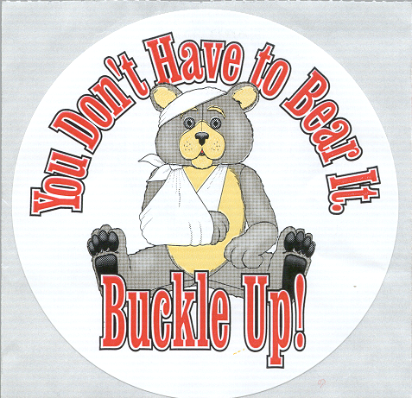
Child safety seats with Teddy Bear Stickers are eligible for replacement through the Teddy Bear Sticker Program. A Teddy Bear Sticker is placed on all child safety seats distributed though our Mini-Grant program. It is identified by the “You Don’t Have to Bear It – Buckle Up” logo featuring a Teddy Bear with his arm in a sling. Stickers may be found anywhere on the back, sides or bottom of a child safety seat.

The Injury Prevention Program also provides safety incentive items for all Fax Back Forms received regarding crashes involving a child age 8 or younger. Safety incentive items include bike helmets, smoke alarms, educational coloring books, safety brochures, buckle up stickers, and buckle up bears. These items can be used to support other injury prevention programs at your agency, and you may indicate which items you prefer on the Fax Back Form at the time of submission.

If you have any questions regarding the Teddy Bear Sticker Program, please do not hesitate to contact me at 404-657-2923 or via email at injury@dhr.state.ga.us

