Service Line Request Web Entry:

- Log into Medical Review Portal
- On the Secure Home page, click Enter a New Authorization.
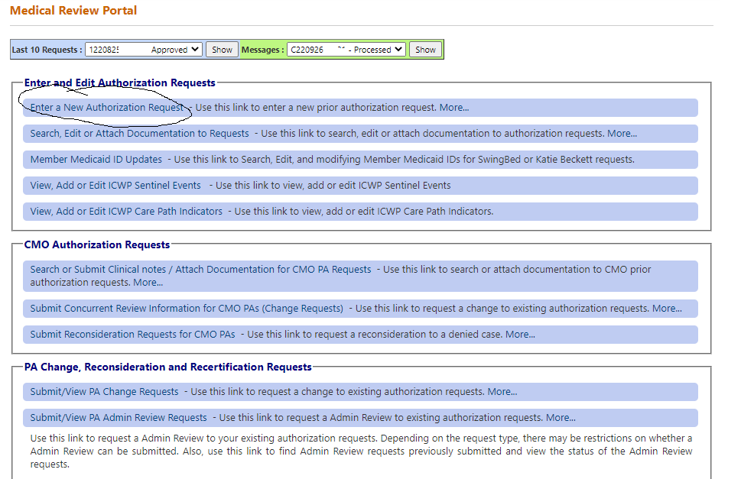

- Click ICWP DMA 80 Services.
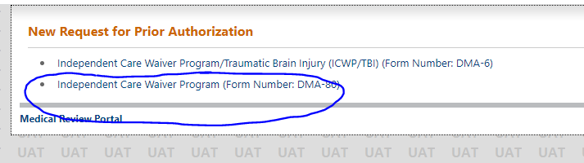

- On the next window, the ICWP provider’s ID is prepopulated based on portal login credentials.
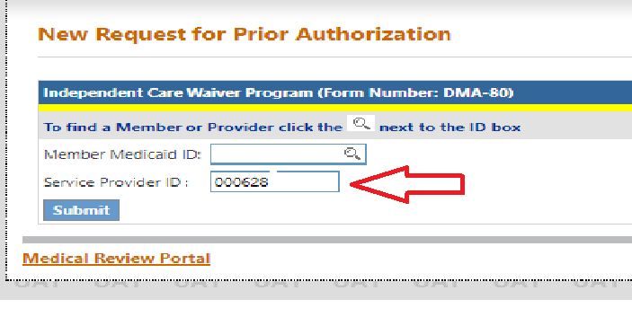

- Enter the member’s Medicaid ID then click Submit
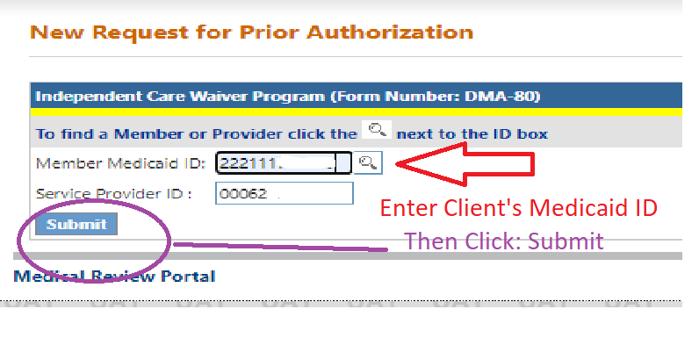

- Enter the approved ICWP DMA6 number.
- Click Submit. The system validates that the LOC is approved and is associated with the Client’s Medicaid ID.

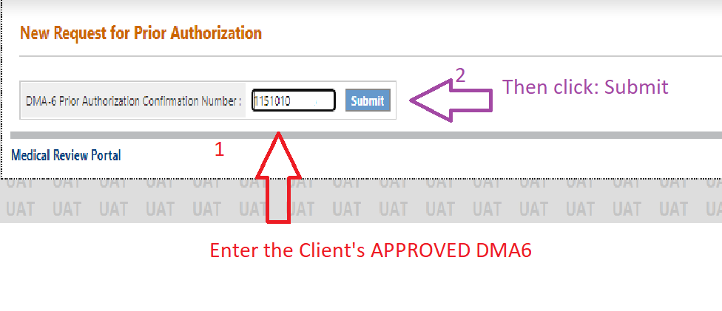

- The ICWP DMA 80 PA will open with the case manager and member information populated on the form.
- The Case manager will need to enter the contact information. Please make sure valid information is used for ‘Contact Information’ as it is often used to contact the provider when there is an issue with the PA.
- Enter the diagnosis code for the member’s primary diagnosis related to ICWP services.
- The system populates the diagnosis description.
- Enter the date that the diagnosis was established; if not known, enter the date that the member started in ICWP.
- Click the ‘Primary’ button and then click Add.
- When Add is clicked, the diagnosis is added to the request and a new blank diagnosis line becomes available if other diagnoses need to be added

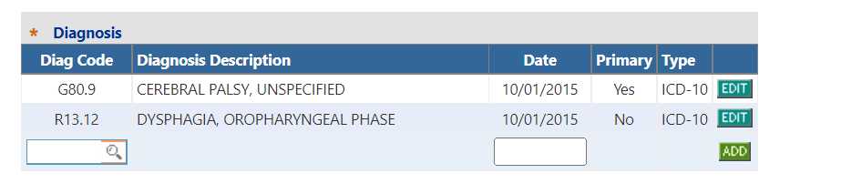

- Circled area “1,2 and 3” (seen below) will be enter the same as you have always done when entering your case manager service PA.
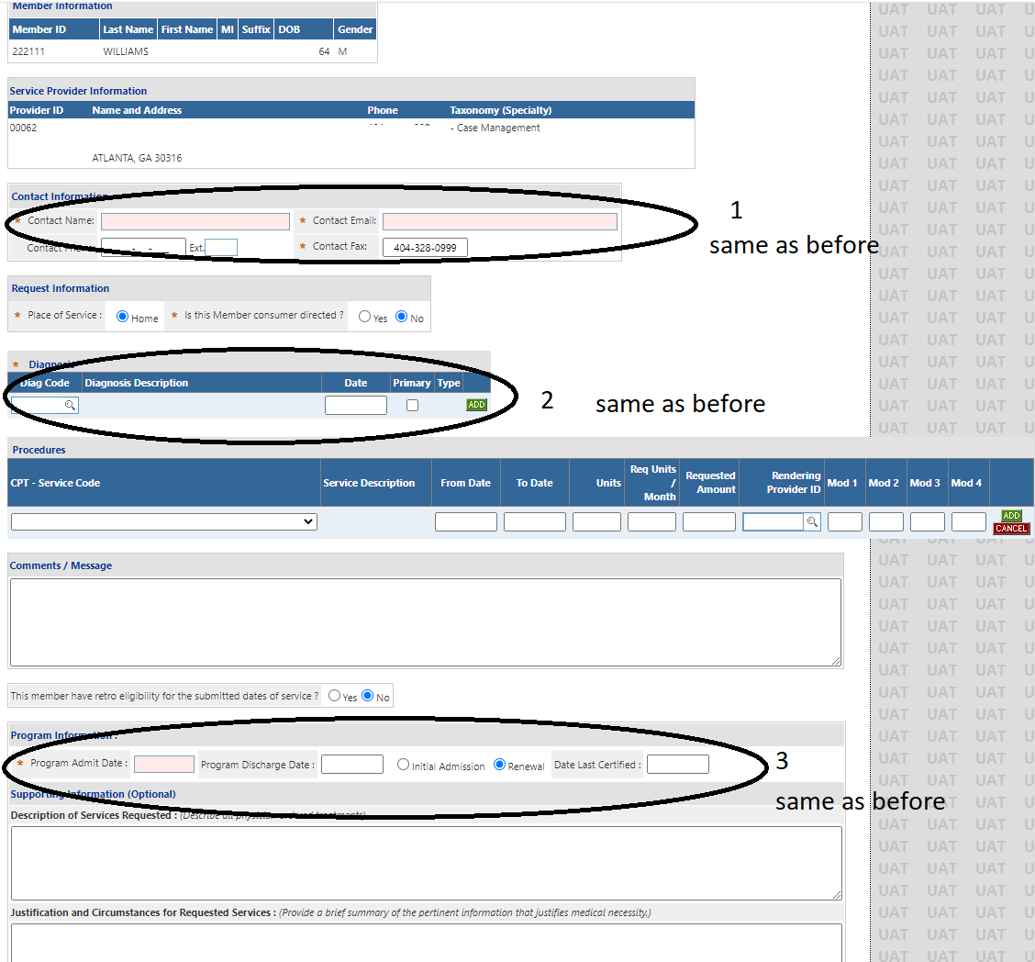

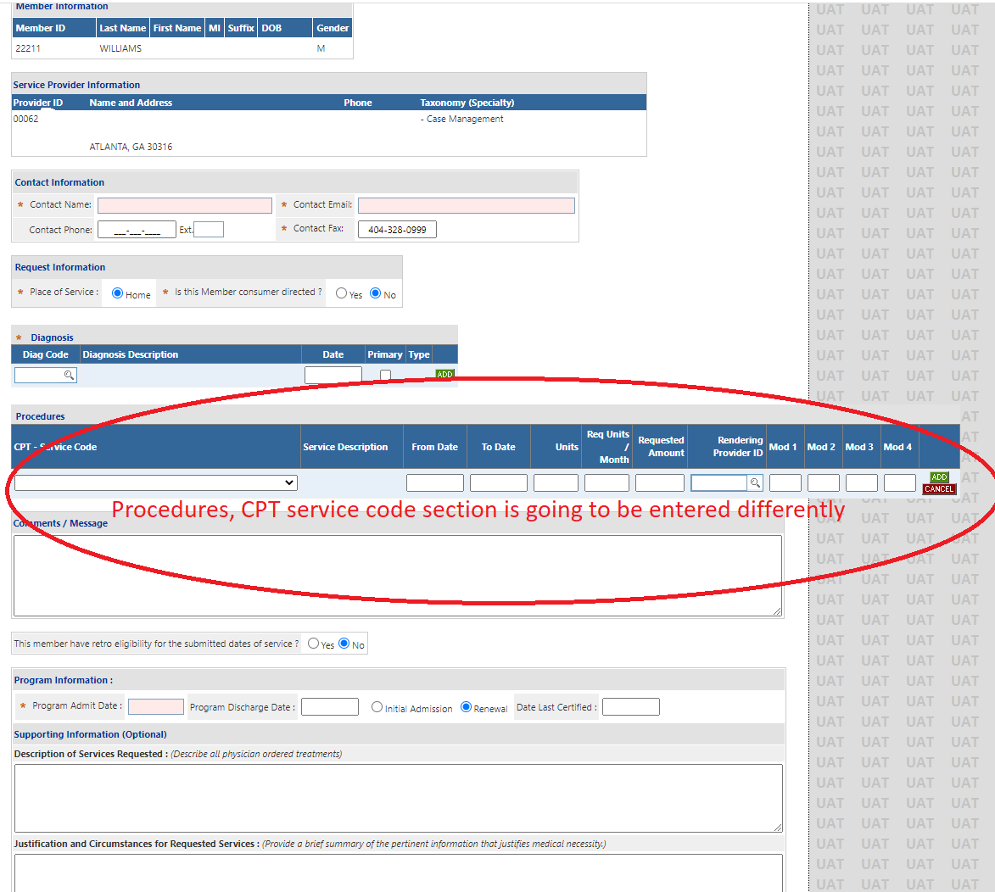

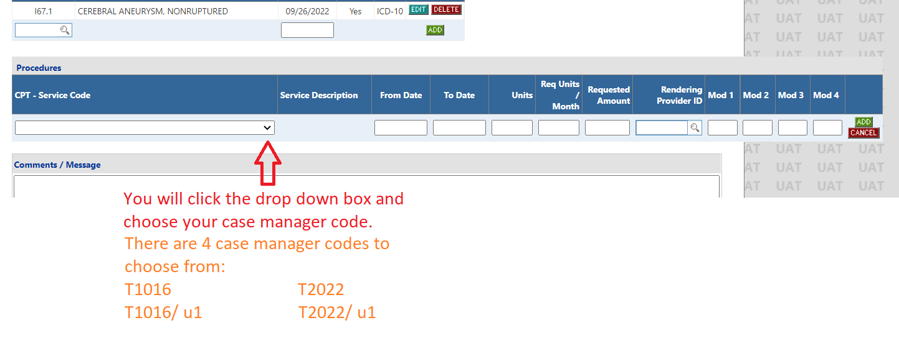

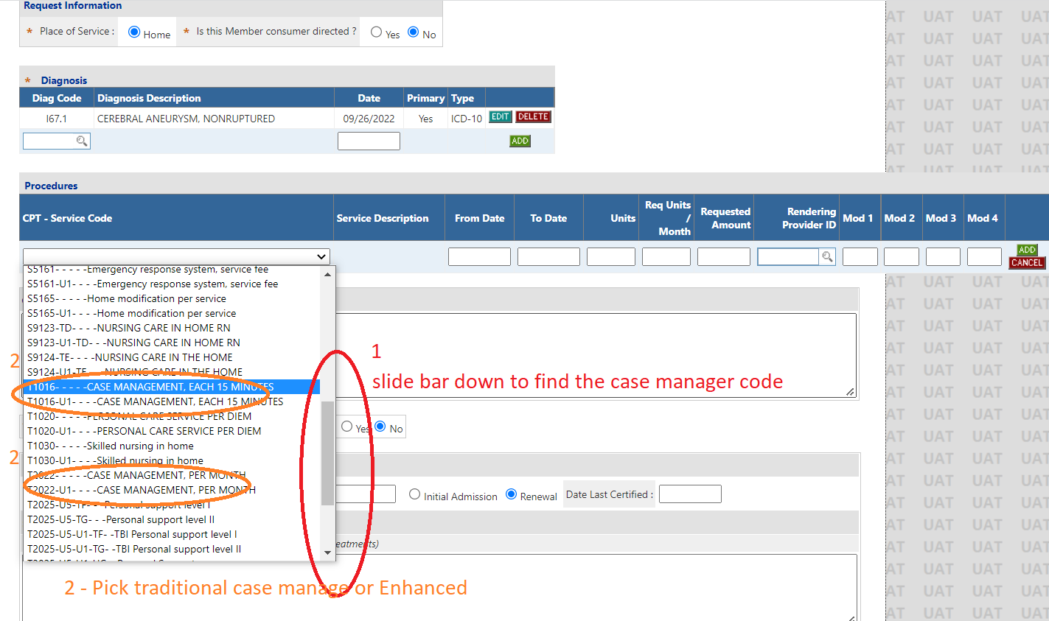

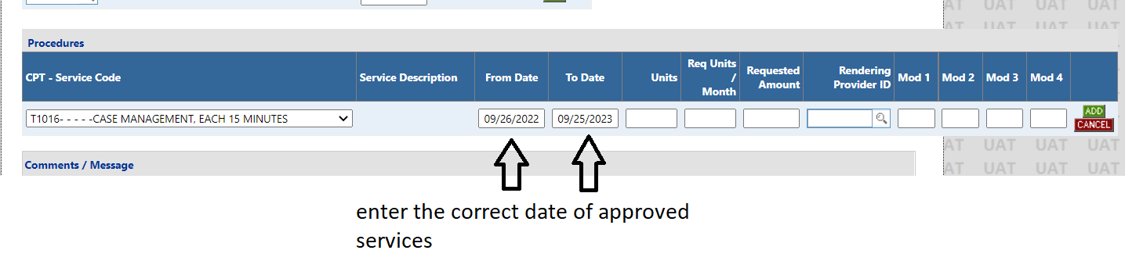

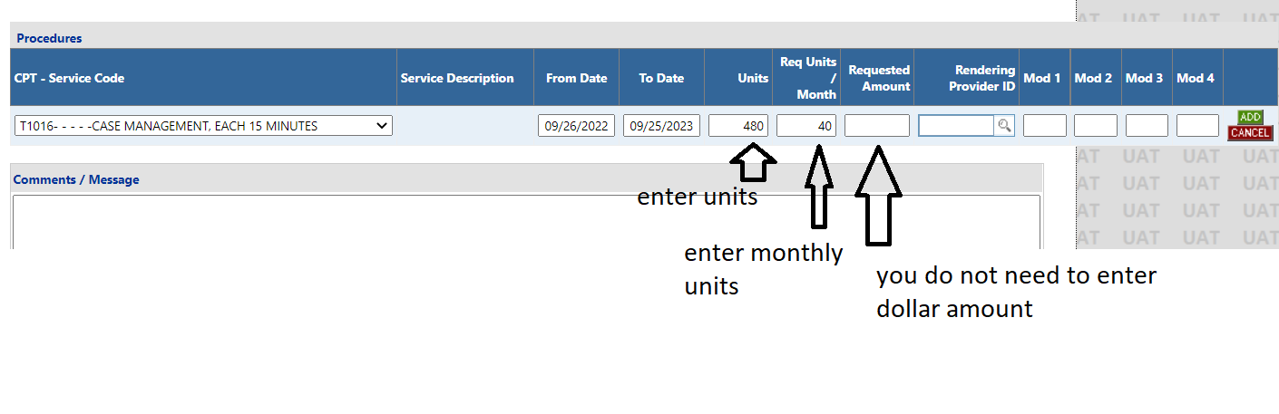

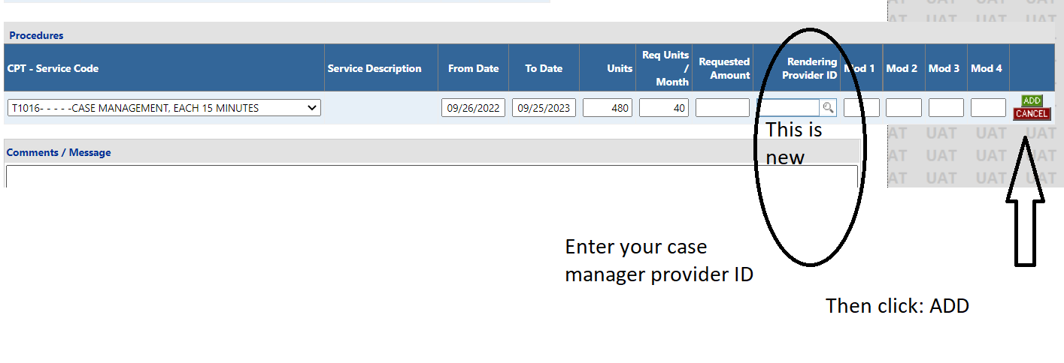

- The CM service is added to the PA and another blank service line becomes available to enter another service.
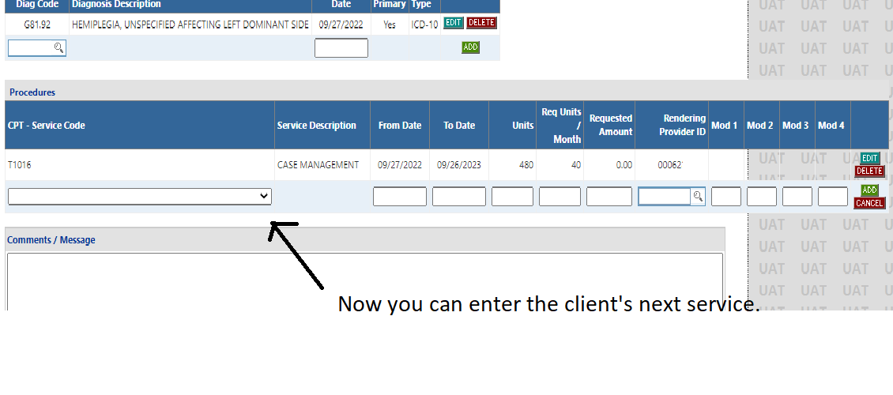

- In the ‘CPT - Service Code’ box, search for the code of the service you need to enter.

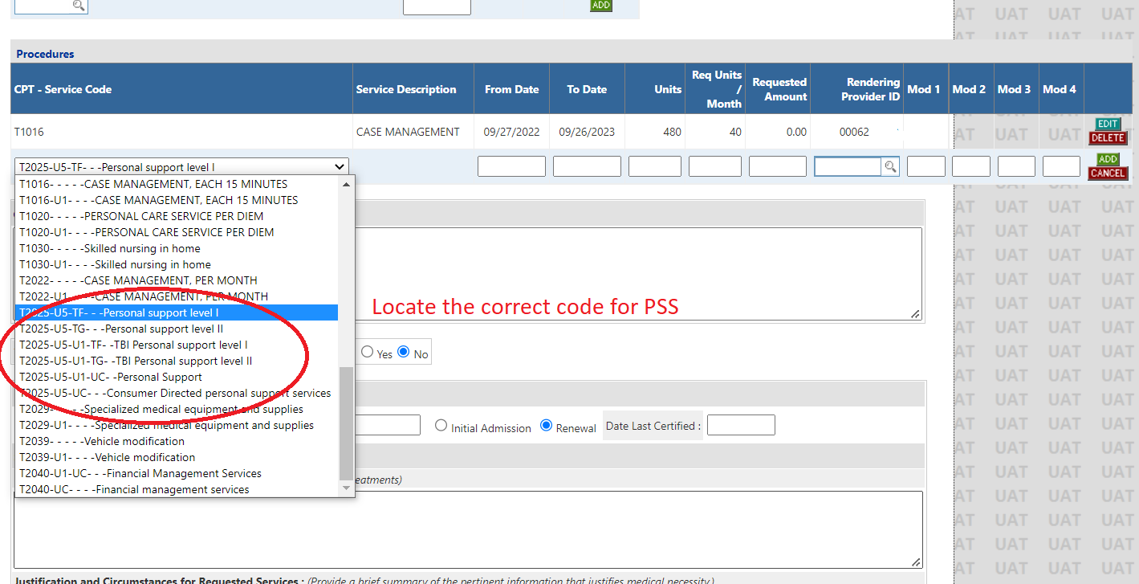

- Enter the first date of service in the ‘From Date’ box and the end date of in the ‘To Date’ box.
- The date span cannot exceed one year.
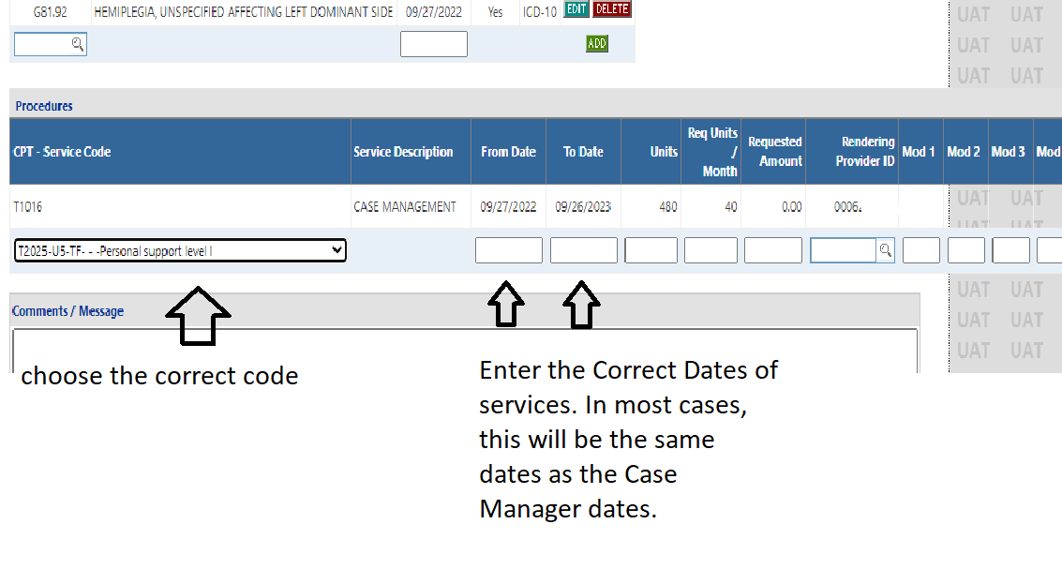
- Enter the Yearly total units requested for the service date span entered.
- Enter the Monthly units of service requested.
- There is no need to enter the dollar amounts.

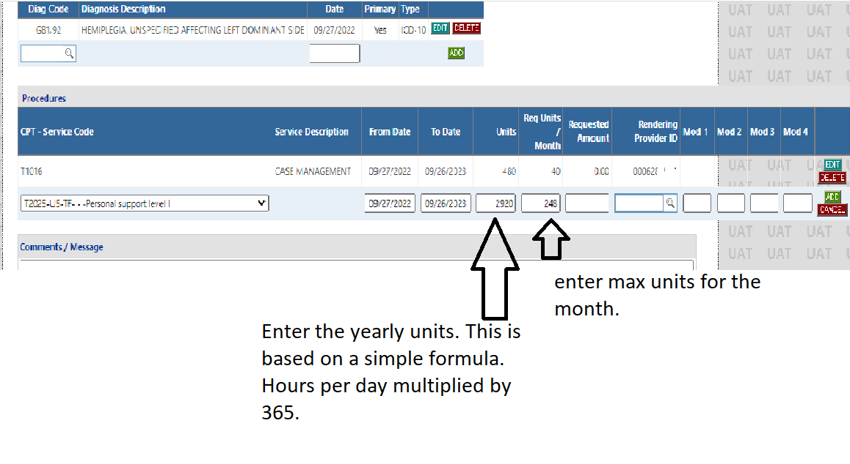

- Enter the provider ID of the provider who is rendering the service. You can get the Provider ID from the agency or from the list provided by DCH. 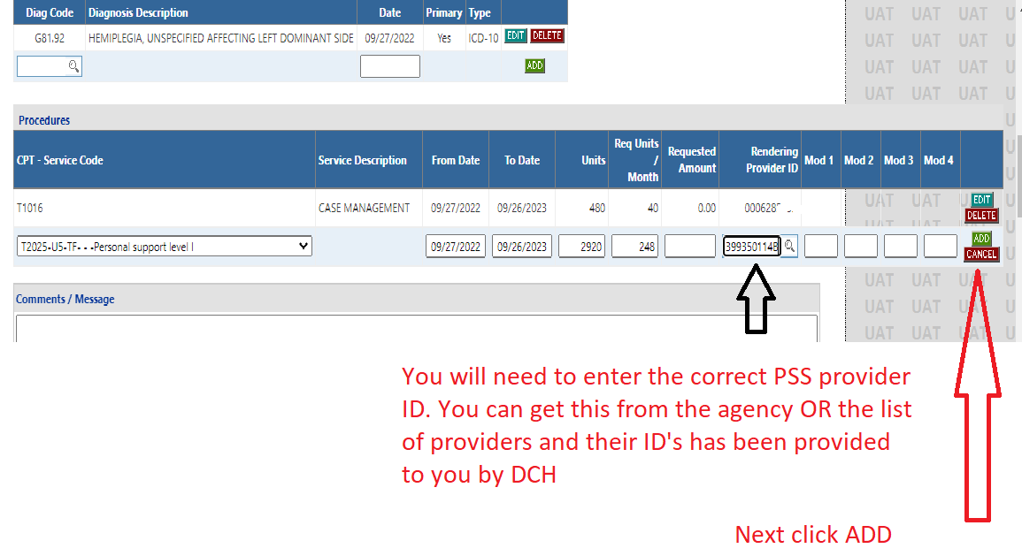

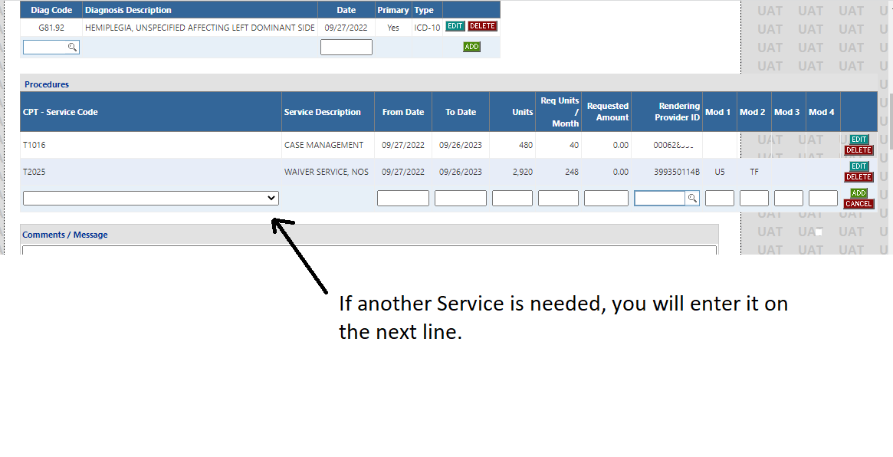
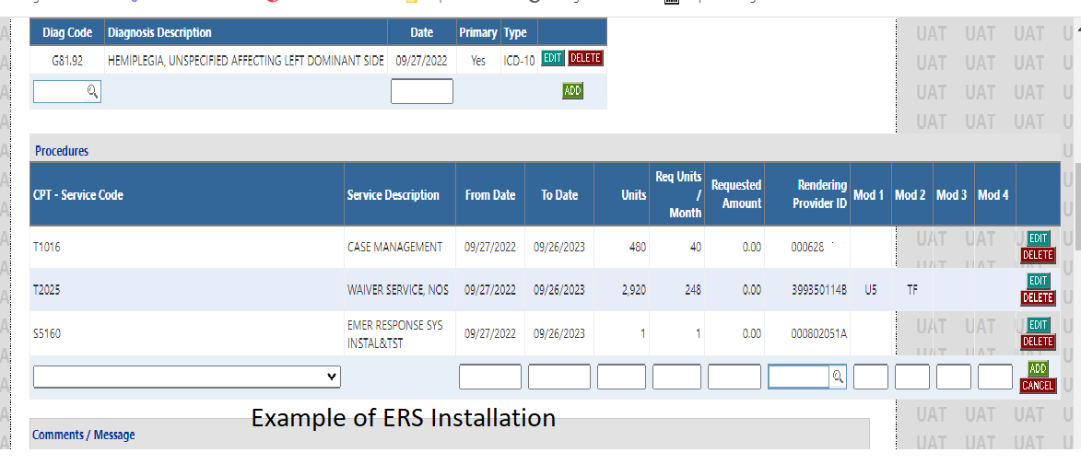

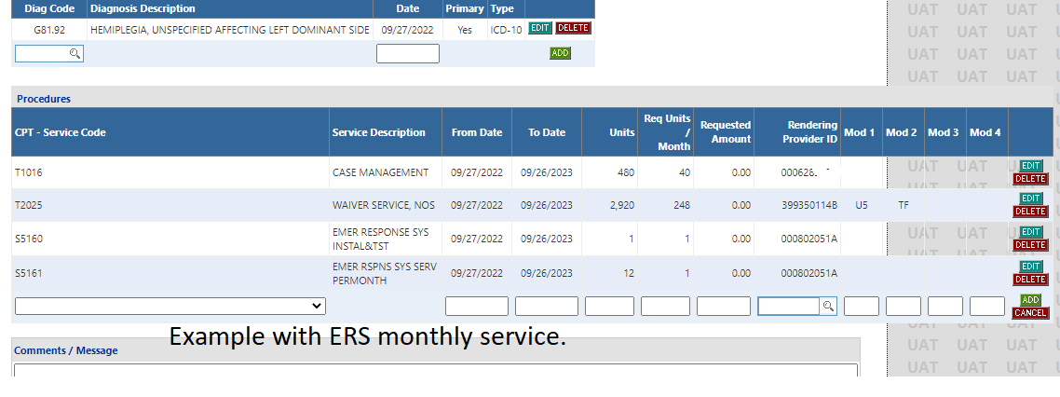

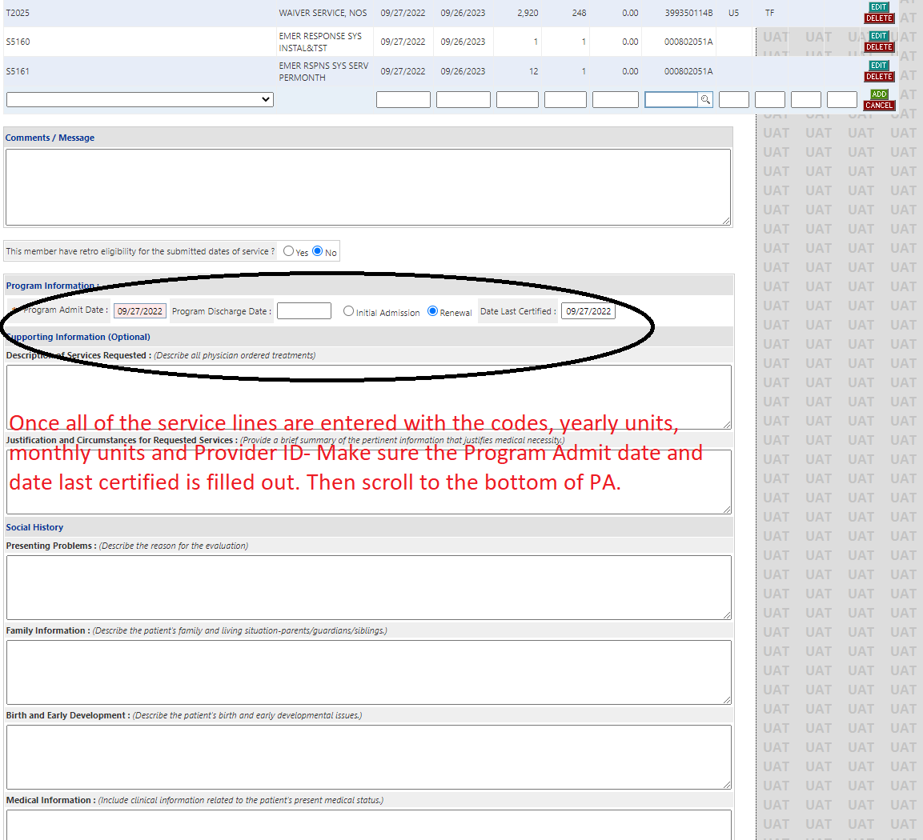

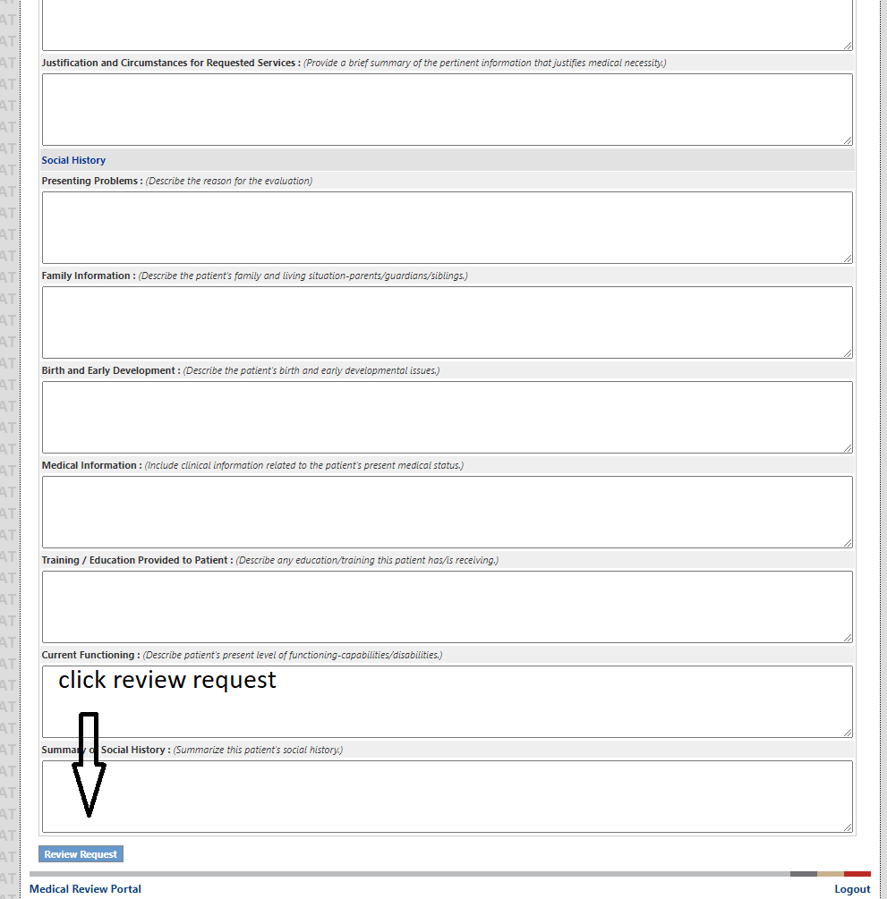

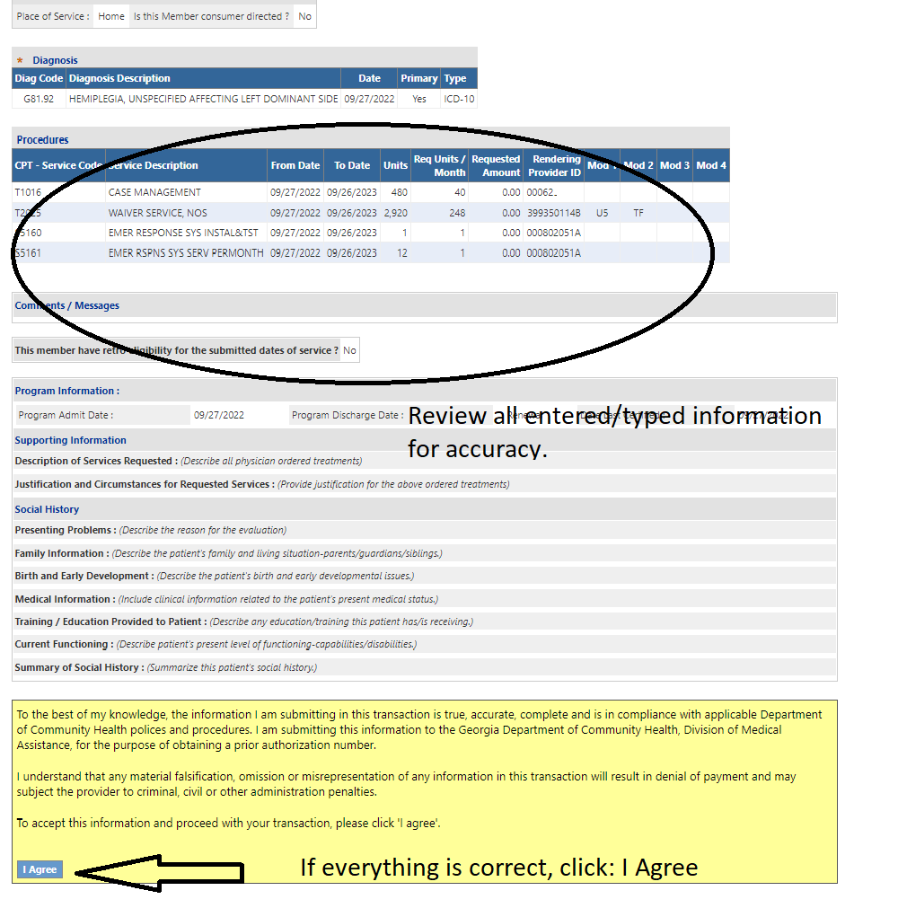

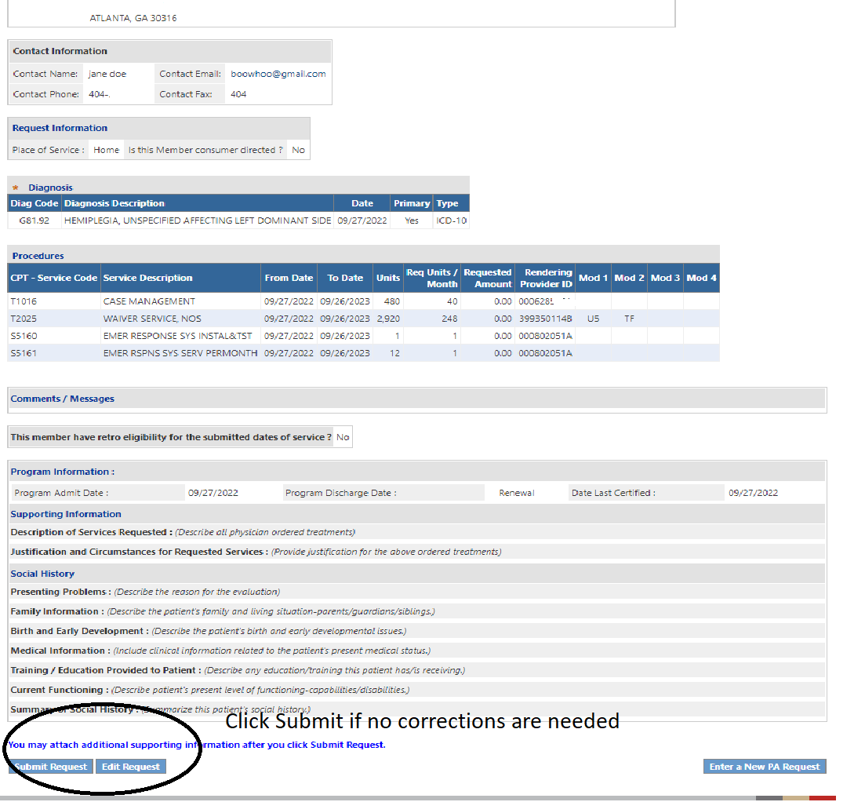

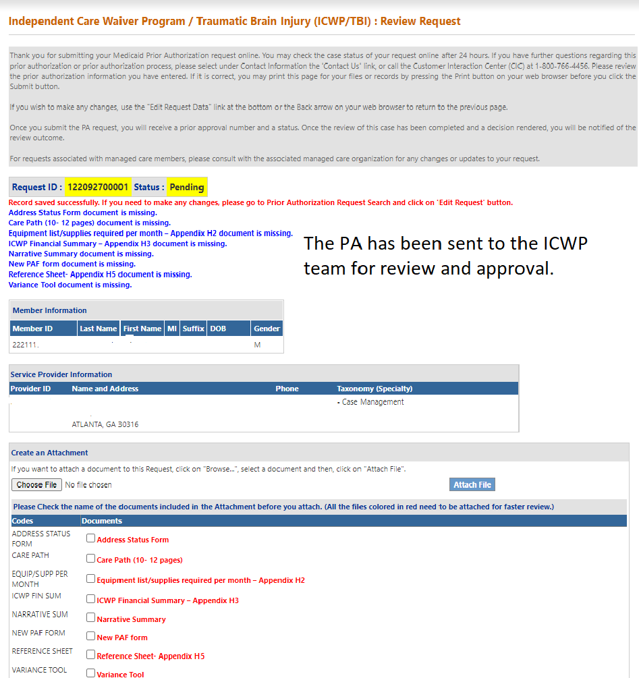

- Case Managers will not be required to enter supply DMA 80s.
- The ICWP Supply DMA 80s will be entered by the supply provider.
- DCH will notify the other ICWP service providers of this change via GAMMIS.

ISSUES:
Acumen: TBI CDC will need to be entered on a separate PA.
Wrong dates: will result in a withdrawal and CM will need to reenter the request.
Missing modifiers: will result in a withdrawal and CM will need to reenter the request.
Wrong Provider ID: will result in a withdrawal and CM will need to reenter the request.

