Steps to enter
Addendums/ Change Request

To submit a request for an addendum/change request, start by opening the Provider Workspace.
- Click Submit/View PA Change Requests.
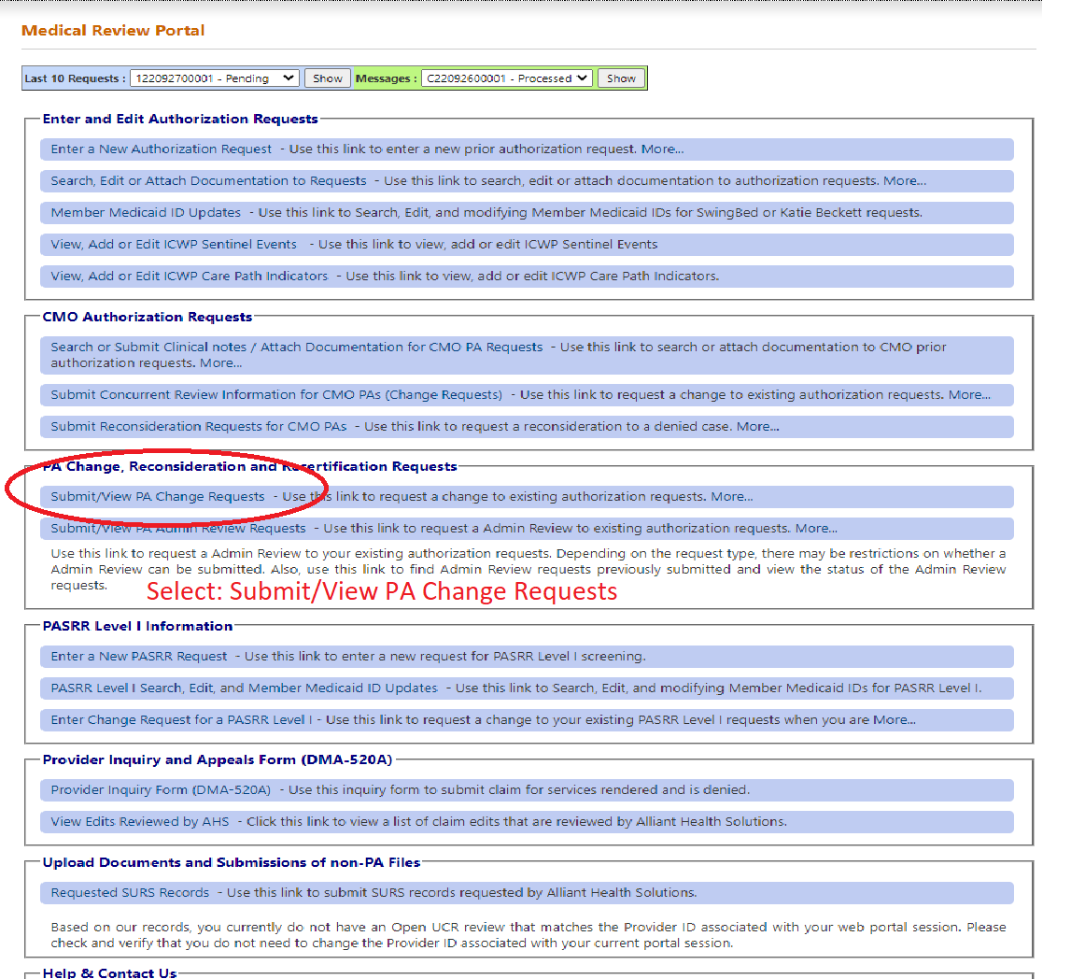

- The Request Search page will come up with your CM provider ID populated.
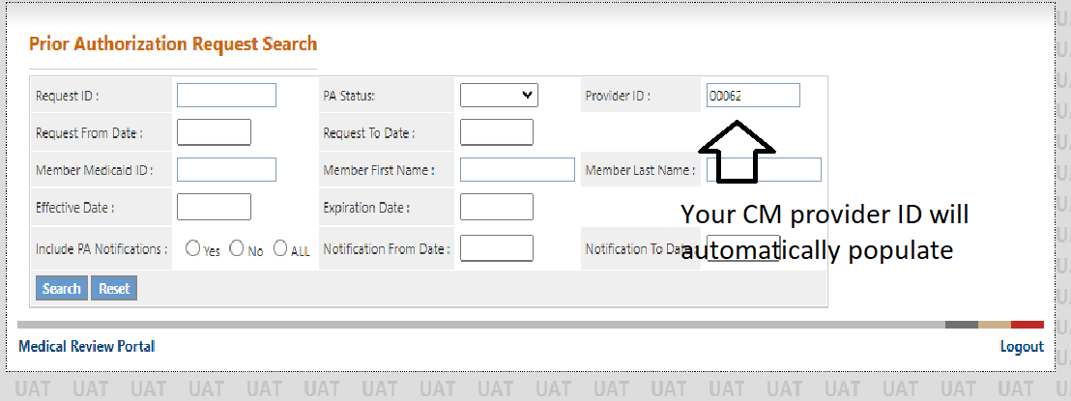

Search for the ICWP DMA 80.
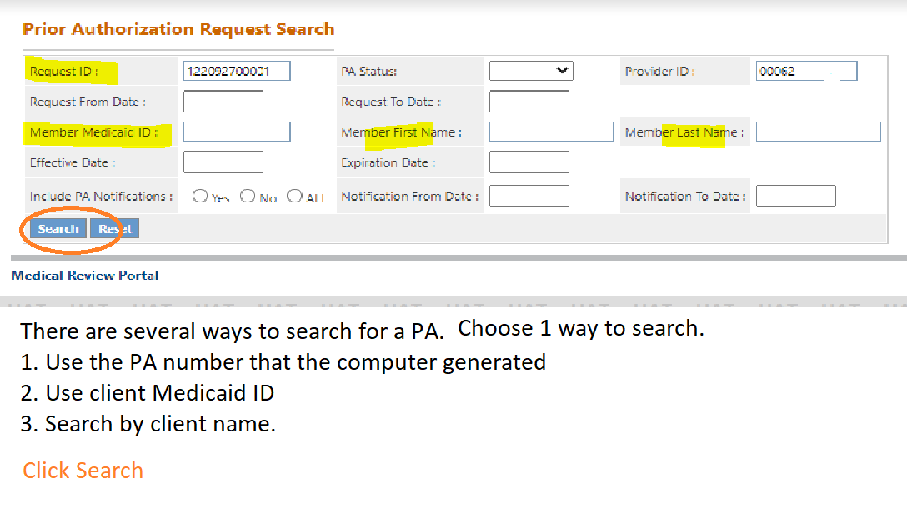

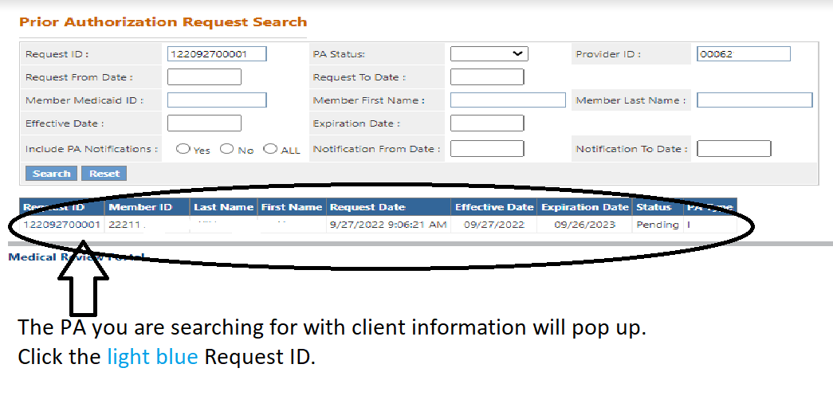

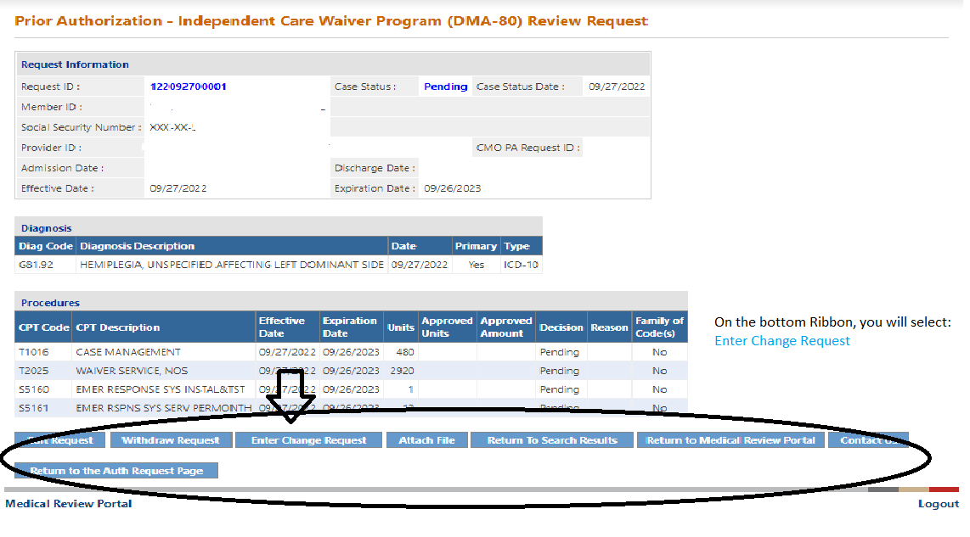
The “Ribbon” at the bottom will give you several options. Select Enter Change Request.

The change request screen will pop up.
The sections in pink must be filled in.
- Describe what is being requested
- What has happened to require a change request?
- Select a Rationale from the check boxes that best match
- Click submit
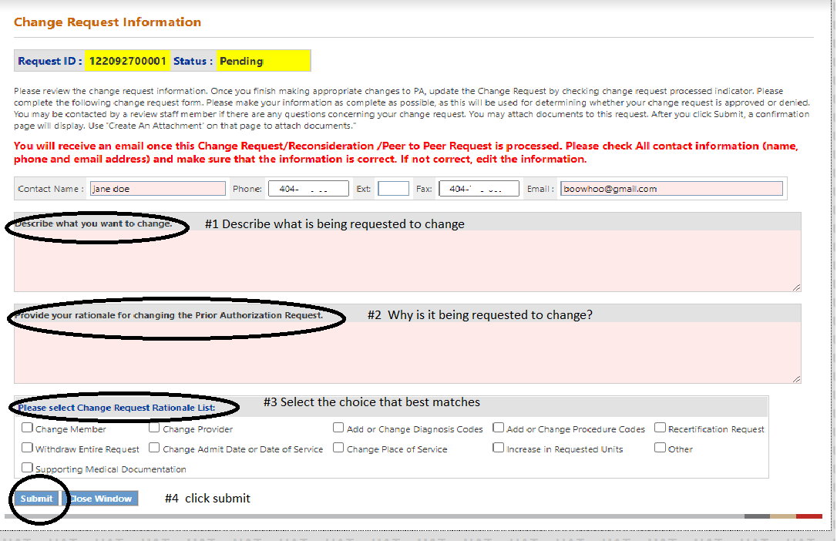

Addendums (change requests) will still require completing and submitting the Appendix U.
Additional medical documentation may also be requested in order to make a determination.
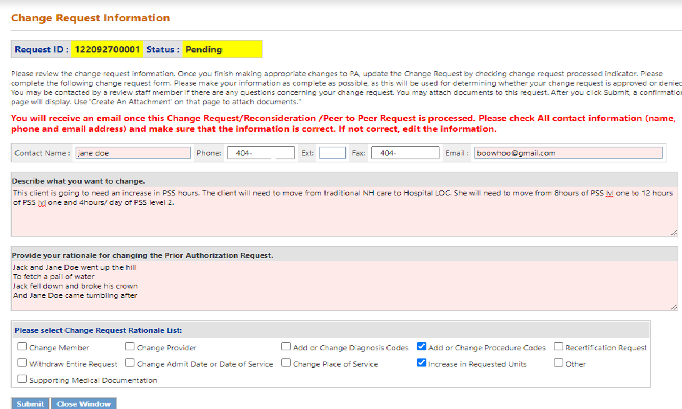
You will be able to attach any needed documents after clicking Submit.

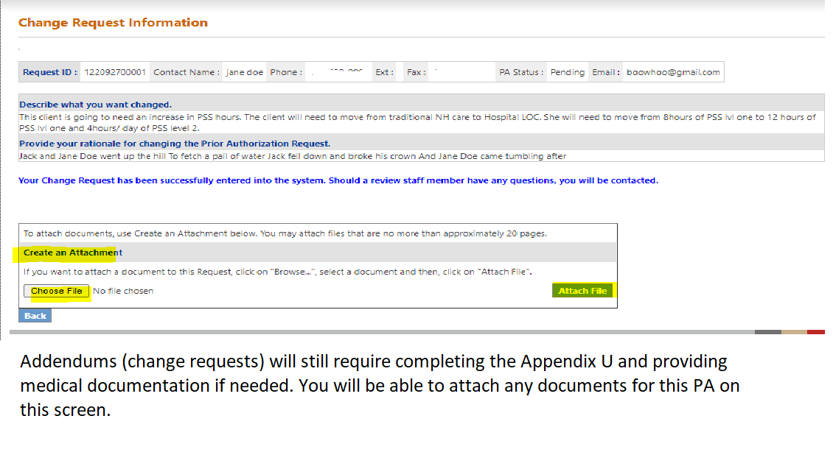

The addendum/ change request will be sent to the review team for determination and processing.

To search the status of a request change.

Return to the main Provider Workspace page.
Click Submit/view PA Change Requests.
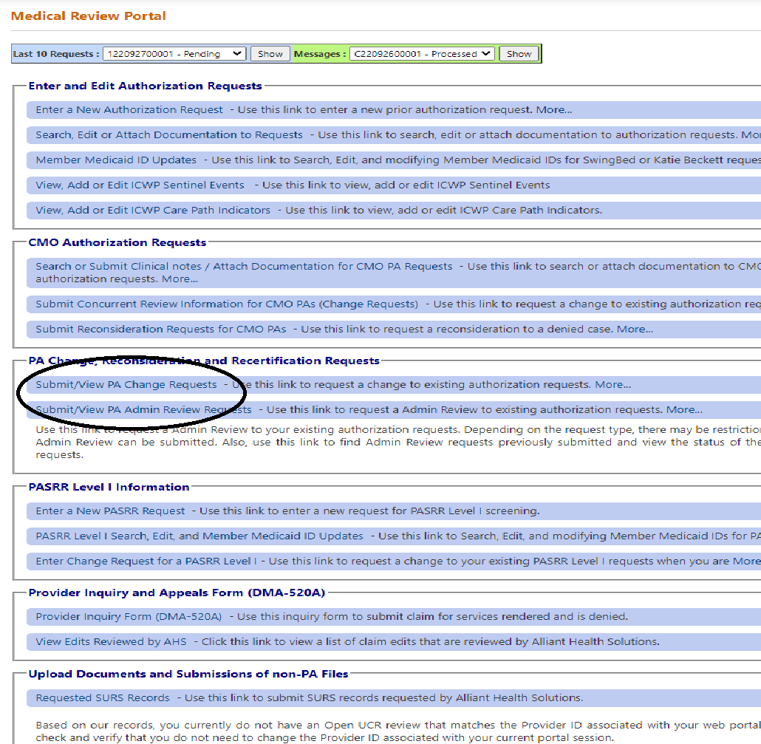
The Request search page will open up.
Enter the Client or PA information and click Search.
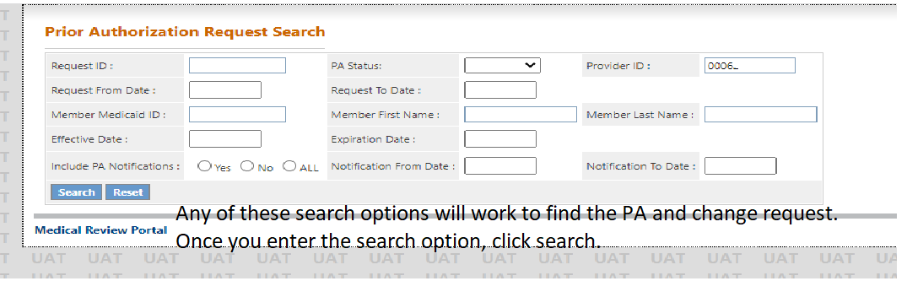

Client and PA information will pop up at the bottom of the request.
Click on the client PA you are looking for.
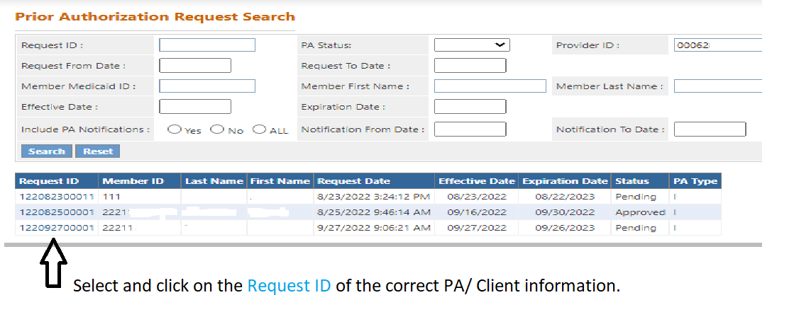

The PA information will open.
You will be able to see if the change request has been Processed, Granted or Denied.
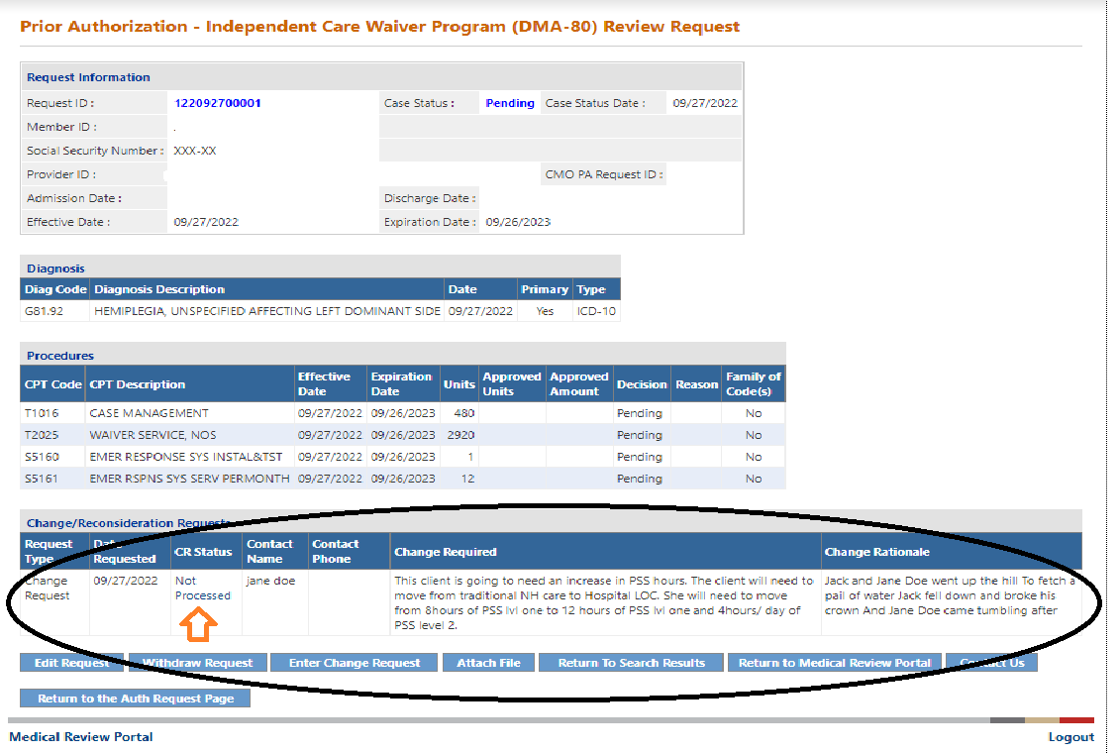

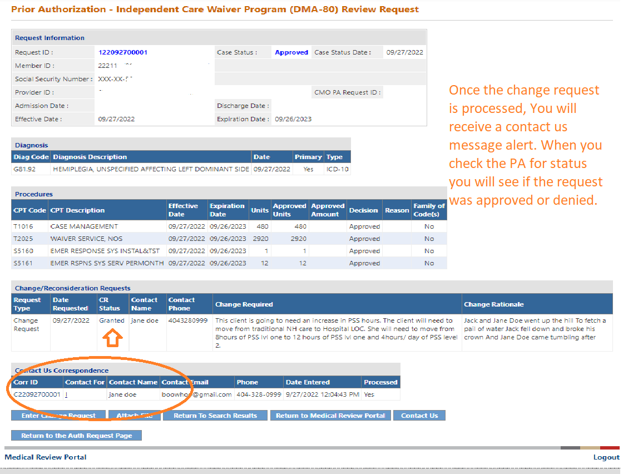

Contact us Computer generated message:
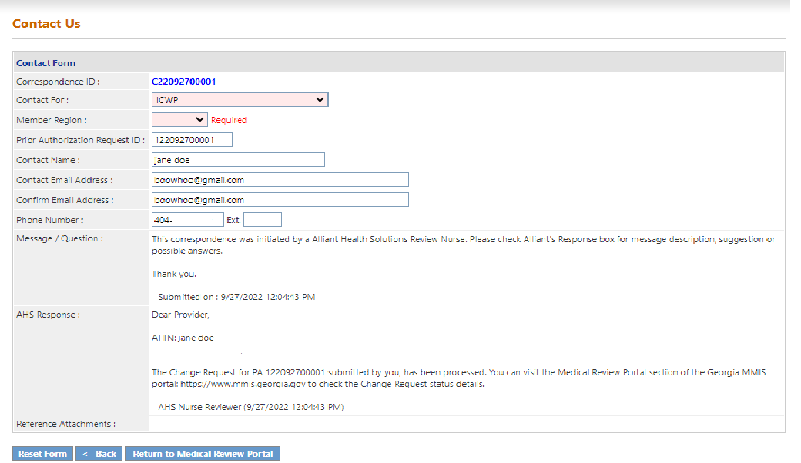

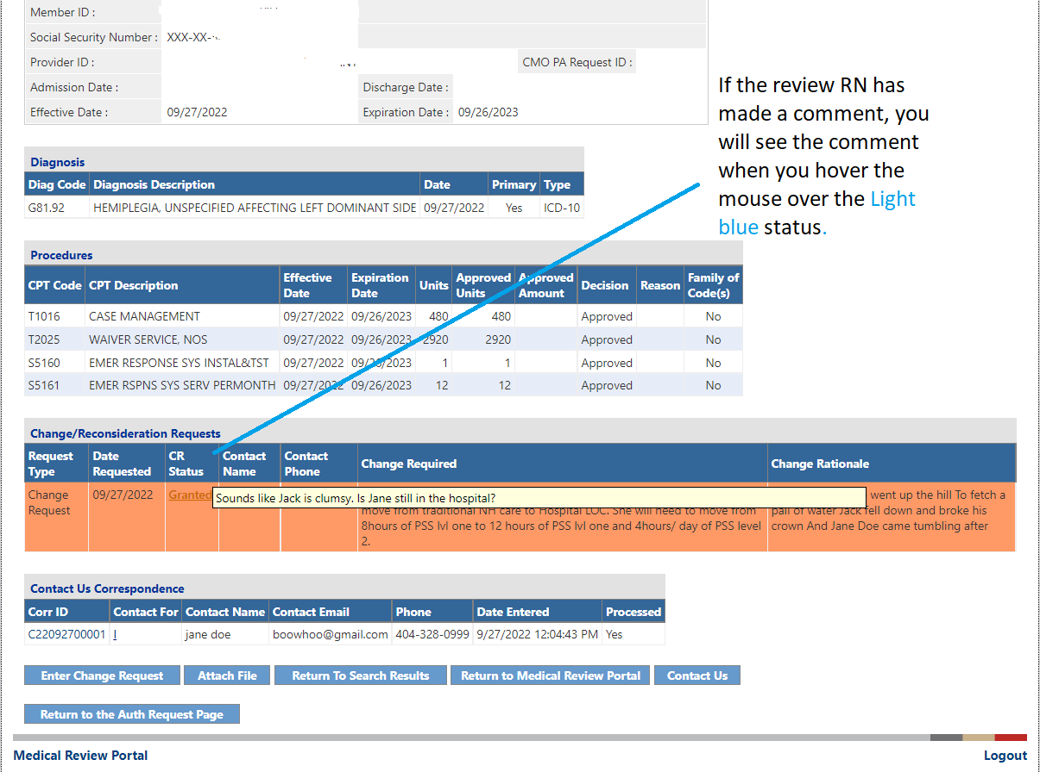

The review nurse will make changes to the DMA 80 for addendums. You will not have to end dates or change units for addendums during the course of the care plan year.

